Chapter 20 –Patterns and UML – Test Questions
These test questions are fill-in-the-blank, multiple choice, and true false. The multiple-choice questions may have more than one correct answer. Mark all of the correct answers for full credit. True/false questions require an explanation in addition to the true/false response. If the response is false, a correction is required.

True False:
Comment required.
- Design patterns are restricted to particular programming languages, of which C++ is one.
Answer: False
Explanation: One of the features of patterns and UML (Unified Modeling Language) is that they apply to any problem and any programming language that supports classes and features for Object Oriented Programming.
- UML is graphical language for designing programs.
Answer: True
Explanation: The statement is true but more should be said. UML is a graphical, one might say, iconic, language used for designing and documenting software created within the object oriented programming framework.
- UML requires that the programmer understand every detail and dark corner of C++ to be useful.
Answer: False
Explanation: You need the mainstream parts of C++, including the parts that support OOP. If the student has an understanding of much of this book, UML should not be a problem for her.
- A pattern is a design principle that solves a problem that occurs over and over.
Answer: True
Explanation: The text says that a pattern is a design principle that applies across several different kinds of applications.
- Patterns are so general they need not make assumptions about the application to which it is being applied.
Answer: False
Explanation:
To be substantive, each pattern must make assumptions about its application. The iterator pattern applies to very nearly all containers, but to apply the iterator pattern to a container, the iterator designer must know the structure of the container. You don’t create efficient random access iterators for a doubly linked list.
- Patterns can help organize the presentation and understanding of ideas about software.
Answer: True.
Explanation:
Consider the types of iterator and the several iterator related member functions of the containers. If we had different names and concepts for what we now call begin() and end() member functions, and so on, we might be overwhelmed. With the organization of the iterator patterns, it is easier to remember the details. In fact the iterator pattern is part of a larger pattern, the Container-Iterator pattern.
- The Adaptor pattern transforms a class by layering a new interface over the class.
Answer: True
Explanation: Typically, the stack and queue template adapter containers by default modify the interface of the deque container. These adapters hide the deque interface, and provide interface appropriate to stack and queue respectively.
- The Adaptor pattern changes the class it modifies when it layers a new interface over the class.
Answer: False
Explanation: The Adapter Pattern does not change the class it uses. For example, the stack and queue adapter container classes pass the underlying container as a template parameter. The container type is used as a type for a variable within the container. The class is not changed.
- UML has annotations for inheritance and data flow.
Answer: True.
Explanation: Inheritance is of importance in OOP, as is the flow of data between classes. Notation is provided.
- UML class diagrams by themselves are not of much utility.
Answer: True
Explanation: There is a need for notation for relations between classes, groupings, inheritance, libraries, and so on. These are provided by the full UML but are only mentioned in the text. The interested student should consult the references given in the text.
- UML provides no facility for describing libraries.
Answer: False
Explanation: Actually, UML has annotations for library-like aggregates.
- If what you need is not in UML, you can add features to UML.
Answer: True
Explanation: UML is designed to be extensible, to enable it to fit the need of the software designer and programmer. There is a prescribed framework so that others can understand other’s (new) UML.
- UML is a standard that is maintained by the Object Management Group, a nonprofit organization that promotes the use of object-oriented techniques.
Answer: True.
Explanation: Languages and tools that are maintained by independent standards bodies tend to be less subject to the politics driven by the desire for financial gain and control of the market by companies.
- UML was designed by Grady Booch, Ivar Jacobson, and James Rumbaugh, based on Simula 68, SmallTalk, C++ and Java.
Answer: False
Explanation: The truth is each of these people had their own graphical or other representation for program design. Each was evolving towards a common design. Booch’s organization acquired one of the other companies, so the third person joined them in developing the Unified Modeling Language. They released UML to OMG for certification and maintenance

Multiple Choice
- If the sort pattern split routine consistently splits the array into two pieces of equal size the runtime is
  - O(N²)
  - O(log N)
  - O(N^{1/2})
  - O(N log N)
  - The run-time depends on too many things to answer this.
Answer: Part d)
- If the sort pattern split routine consistently splits the array into two pieces size 1 and another of size N-1 then the run time is”
  - O(N²)
  - O(log N)
  - O(N^{1/2})
  - O(N log N)
  - The run-time depends on too many things to answer this.
Answer: Part a)
- Consider the quick sort algorithm as implemented in the text using the sort pattern. Which of the following data characteristics give the fastest run time? Explain.
  - An array sorted into increasing values.
  - An array sorted into decreasing values.
  - An array of random values
  - An array that increases for half the array, then decreases
Answer: Part c) an array of random values will have the least chance of having the split create consistently equal subarrays, hence give a runtime of O(N log N).
Explanation: All the other choices guarantee split gives subarrays of size 1 and N-1, hence give quadratic performance. Part d) requires a little thought, but it too gives quadratic runtime.
- Which of the following is a correct statement about UML class diagrams?
  - The second part of the class diagram contains only private members.
  - The second part of the diagram contains data members
  - The third part of the class diagram contains only public members.
  - The top part of the class diagram contains the class name (or tag).
  - The third part of the diagram contains member functions.
Answer: Parts b), d) and e) are correct.
Explanation: Part a) is close, as data members should be private, but this is not required. Part c) is wrong, since not all function members are public. Some are protected and some may be private.
- Which of the following are true of the Model-View-Controller pattern?
  - This pattern is useful in designing a GUI (graphical user interface).
  - This pattern is useful only in designing end-user computer applications. It is of little value otherwise.
  - This pattern presents a way to separate (at least logically) I/O from the process part of the application.
  - In this pattern, the Controller is the input portion of the task.
  - In this pattern, the View is the input portion of the task.
  - In this pattern, the Controller accepts data and commands from the user, it sends the to the Model. The Model processes commands, operates on the data, and changes the state of the program, notifies the View. The View presents the state of the program.
Answer: Parts a) c) d) and f) are correct, or partially correct.
Explanation: Part a) is omits other uses. Part b) is too restrictive. This pattern has applicability to almost any system, whether application or other system. It is applicable to non-computer systems. Part c) and d) are correct. If these err, it is by omission. Part e) is wrong, the View is the output part of the solution. Part f) is a correct overview of the model.
- Which of the statements are true? UML provides features for:
  - A graphical representation for programs
  - Interaction between classes
  - Indicating member access in a particular class
  - Separating data members from function members
  - Indicating the name of the class
  - Describing programs in a human oriented way
  - Data flow between classes
  - Class grouping
  - Inheritance
  - Library-like class aggregates
  - Extensibility
  - Replacing flow charts, structure diagrams and pseudocode.
Answer: All of these are correct. UML is a well-designed tool for design and documentation of program in a graphical form that is easily read by human beings.
- Patterns, or design patterns
  - Distill programmer experience into models that work
  - Should be taken as a detailed prescription for problem solving.
  - Have become standard and useful tools
  - Have no formalism for expression and implementation of patterns.
  - UML is a formalism to express patterns
Answer: All parts except b) and d) are correct.
Explanation: Part a) may be deduced from the text, but is not explicitly stated there. Part b) is explicitly contradicted by the text. “One should not follow all the fine details of a patterns.” Optimizations are certainly permitted, and are illustrated in the discussion in the text. Part d) is wrong, there are several formalisms, including UML.
- This chapter has describes and applied the following patterns:
  - Iterator
  - Container-Iterator
  - Adapter
  - Model-View-Controller
  - Divide and Conquer Sort
Answer: The text treats all these algorithms.
- Which of the following statement about UML is true? In the explanation, correct those that are not true.
  - UML is graphical language for designing programs.
  - UML requires that the programmer understand every detail and dark corner of C++ to be useful.
  - UML has annotations for inheritance and data flow.
  - UML class diagrams by themselves are not of much utility.
  - UML provides no facility for describing libraries.
  - If what you need is not in UML, you can add features to UML.
  - UML is a standard that is maintained by the Object Management Group, a nonprofit organization that promotes the use of object-oriented techniques.
Answer:
Parts a), c), d), f), and g) are correct, but a) and d) are incomplete or need elaboration.
Explanation:
Part a) is incomplete. UML is for documenting and designing programs as well as for general systems. Part b) is wrong. The C++ in the text is not all of the language, yet this provides a sufficient basis to effectively use UML. Part d) is true, but with the additional annotations mentioned in c), denied in e) and mentioned in f), the class diagrams become quite useful. Part e) is wrong. UML provides notations for collection of classes and library-like collections.
- Which of these remarks about patterns is correct?
  - Design patterns are restricted to an official list of particular programming languages, of which C++ is one.
  - A pattern is a design principle that solves a problem that occurs repeatedly.
  - Patterns are so general they need not make assumptions about the application to which it is being applied.
  - Patterns can help organize the presentation an understanding of ideas about software.
Answer: Parts b) and d) are correct.
Explanation:
Part a) is wrong. Pattern use is not restricted to any particular language, so long as support for classes and inheritance is available. Part c) is wrong, to be substantive, the pattern must make some assumptions about the domain of the problem to which the pattern is to be applied.

Free Form Questions:
- Give at least two STL containers that fit the Adapter Pattern as described in the text.
Answer: The stack, queue, and priority queue are the adapter containers.
- Describe the sort pattern. Discuss the quick sort routines in terms of this pattern.
Answer:
Sort array
1)Get split point and Split two parts
2)Sort first part(recursive)
3)Sort second part (recursive)
4)Join sorted parts.
Explanation:
Quick sort:
1)Split into what we hope are roughly equal parts,
this may not be the case.
Postcondition on the split: Each element in upper
half is >= each element in the lower half. The hard
work is done here.
2)Recursively sort the first part
3)Recursively sort the second part
4)The join is trivial
The division into two pieces of nearly equal size will cause the routine to run in N log N time, that is, O(N log N) time. There is a non-negligible probability that the arrays will consistently be of size 1 and size N-1 respectively, which will result in O(N²) run time
- Describe the sorting pattern. Discuss the Merge sort routines in terms of this pattern. Answer:
Sort array
1)Get split point and Split two parts
2)Sort first part(recursive)
3)Sort second part (recursive)
4)Join sorted parts.
Explanation:
Merge sort:
1)Split is trivial: calculate the
middle - (begin – end);/2
The parts differ in size by at most 1.
2)Recursively sort first part.
3)Recursively sort second part.
4)Merge sorted parts
Postcondition on the Merging: The result is sorted.
(The hard work is done here)
The division into two pieces of nearly equal causes the routine to run in O(N log N) time.
- Describe the sorting pattern. Discuss the Selection sort routines in terms of this pattern.
Answer:
Sort array
1)Get split point and Split two parts
2)Sort first part(recursive)
3)Sort second part (recursive)
4)Join sorted parts.
Explanation:
Selection sort:
1)Split: two pieces, first with one element at the end,
the other part is one less than the size of the
array. This is the largest possible difference. Split
swaps smallest with begin, and returns begin +1 as
split point.
2)Recursively sort first part (there is only one
element, Display 20.2, line 17 makes sort do nothing)
3)Recursively sort second part.
4)Join is trivial
Postconditon on the Joining: The result is sorted.
The division into one piece of size 1 and a second of size n-1 causes the routine to run in quadratic, that is, O(N²) time.
- The UML class diagram is a rectangle that has three sections. Fill in the members with necessary symbols for public, protected and private members.
class Square
{
public:
// unlisted members
void resize(double newSide);
void move(Pair<double, double> point);
protected:
void erase();
// other members
private:
double side;
Pair<double, double> topRtCorner;
};
Put your answer here:
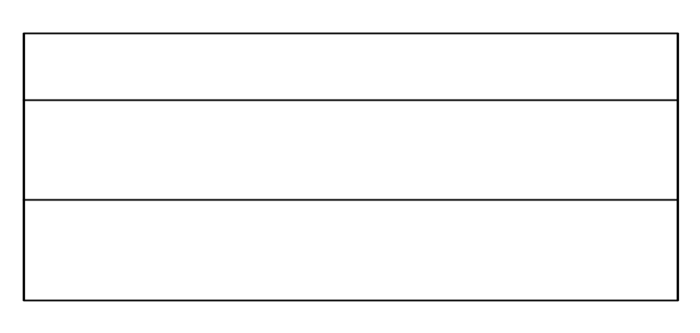

Answer:
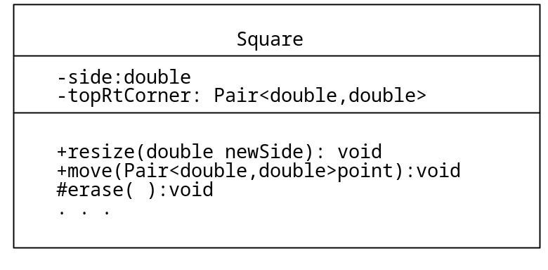
The top section contains the name of the class. The second section contains the data specification for the class. The third section contains the function member. The + sign means public member, the # sign means protected. The – sign means private. The ellipsis (. . .) means there are omitted members.
- Given the class definition, give the class diagram.
class Pair
{
public:
Pair();
Pair(double, double);
void setFirst(double);
void setSecond(double);
double getFirst();
double getSecond();
protected:
double first;
double second;
};
Put your answer here:
Answer: There is no unique answer, but this is one suitable answer.
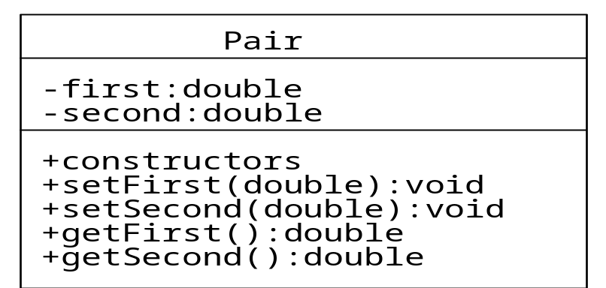
- Describe the queue in terms of the Model-View-Controller pattern.
Answer: The View displays the front of the queue and whether the queue is empty. The Controller gives commands push and pop to modify the state. The Model changes the state and notifies the View of this change.
- Describe a GUI file manager in a windowing system in terms of the Model-View-Controller model. A file manager might be the Windows Explorer under MS Windows.
Answer:
The View could be the object that displays the names of files (and attributes, if attributes are requested by a command from Controller) in the directory being managed. The Controller could be an object that issues commands when buttons or menus are clicked. The Model could add or delete filenames in response to the commands, and notify View when a change has been made.

